Lab: 1

Introduction
Data mining involves extracting meaningful patterns from large datasets. However, raw data is often incomplete, inconsistent, and noisy. Therefore, data preprocessing is an essential step to improve data quality before applying analytical or machine learning techniques.
This report presents various preprocessing techniques such as handling missing values, cleaning data, detecting outliers, scaling features, and encoding categorical variables.

Objectives
The main objectives of this experiment are:
- To explore and understand the dataset
- To handle missing and inconsistent data
- To perform statistical analysis
- To detect and treat outliers using IQR method
- To apply feature scaling techniques
- To convert categorical data into numerical format

Data Understanding

Load the dataset
The dataset was loaded using the pandas library. The first 10 rows were displayed to understand the structure of the data.
- Data types of each column were checked.
- Missing values were identified in multiple columns such as Age, Unit_Price, Quantity, Gender, and City.

Code:
import pandas as pd
import numpy as np
df = pd.read_csv("data.csv")
print(df.head())
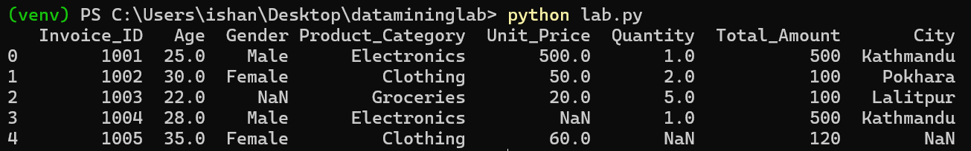

Display first 10 rows
Code to display the first 10 rows:
print(df.head(10))
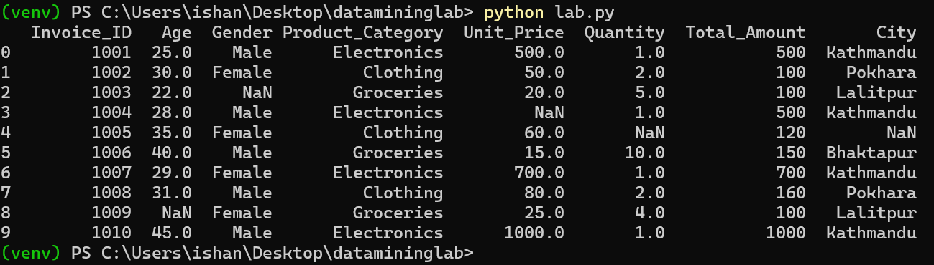

Check data types of each column
Code to check the data type:
print(df.dtypes)
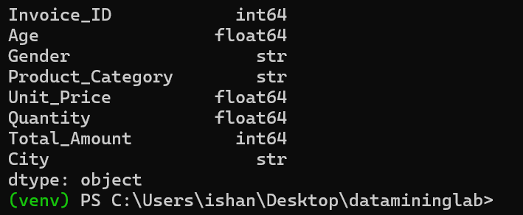
Code to display data info of first 10 rows:
print(df.info(10))
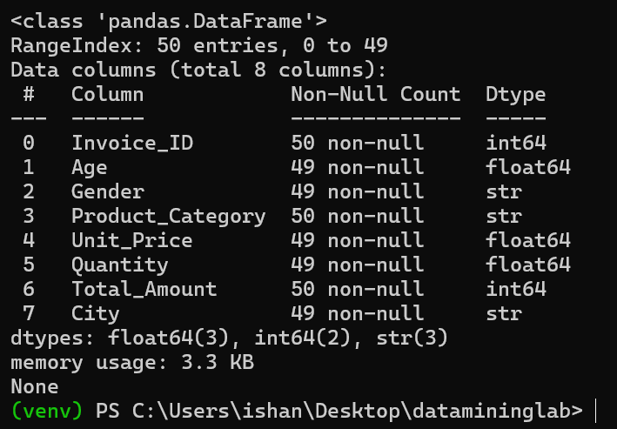

Find total number of missing values in each column
Code to find total number of missing values in each column:
print(df.isnull().sum())
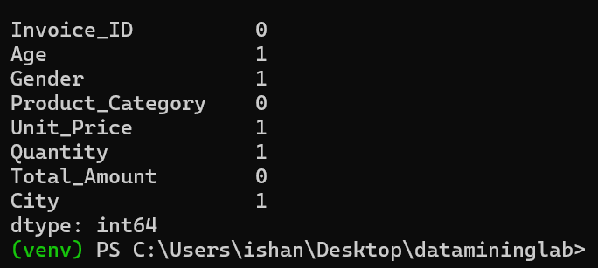

Missing Data Handling
The missing values were handled as follows:
- Age replaced with mean
- Unit_Price is replaced with median
- Quantity is replaced with median
- Gender is replaced with mode
- City is replaced with constant value "Unknown"
This ensures no null values remain in the dataset.

Filling missing data
Code:
df['Age'] = df['Age'].fillna(df['Age'].mean())
df['Unit_Price'] = df['Unit_Price'].fillna(df['Unit_Price'].median())
df['Quantity'] = df['Quantity'].fillna(df['Quantity'].median())
df['Gender'] = df['Gender'].fillna(df['Gender'].mode()[0])
df['City'] = df['City'].fillna("Unknown")
print(df.isnull().sum())
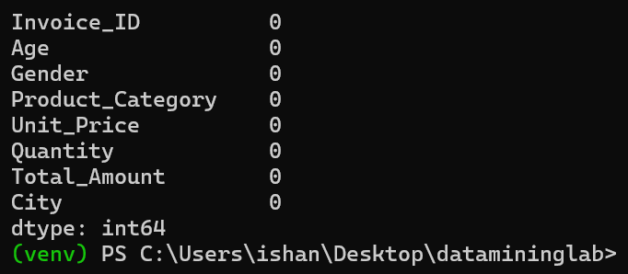

Data Cleaning

Data cleaning is the process of identifying and fixing or removing errors, missing values, and inconsistencies in data to improve its quality and usability.
- Duplicate rows were identified and removed.
- Numerical columns were converted into proper numeric format.
- Categorical values were standardized by converting them into lowercase.

Check and remove duplicate rows
Code to remove duplicates rows:
duplicates = df.duplicated()
print(df[duplicates])
df.drop_duplicates(inplace=True)
print("After removal, number of duplicate rows:", df.duplicated().sum())
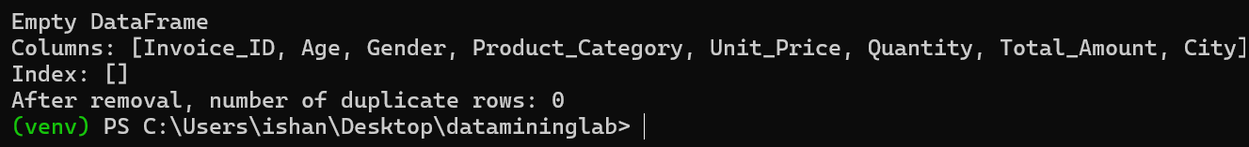

Ensure all numerical columns are in correct format
Code:
numeric_columns = ['Age', 'Unit_Price', 'Quantity']
for col in numeric_columns:
df[col] = pd.to_numeric(df[col], errors='coerce')
print(df.dtypes)
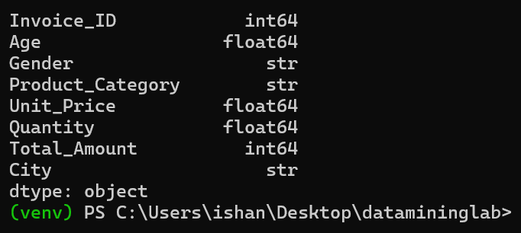

Standardize categorical values
Code to standardize categorical value:
df['Gender'] = df['Gender'].str.lower()
df['Product_Category'] = df['Product_Category'].str.lower()
df['City'] = df['City'].str.lower()
print(df.head(10))
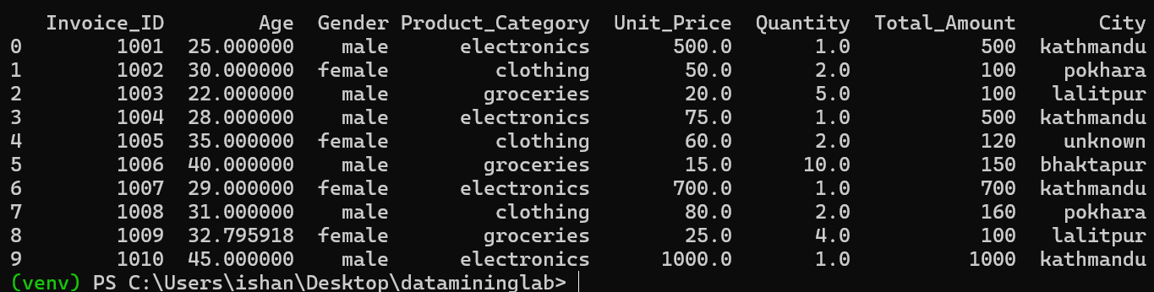

Statistical Measures
The following statistical measures were calculated:
- Mean
- Median
- Mode
Skewness Insight:
- If Mean > Median than data is positively skewed
- If Mean < Median than data is negatively skewed

Calculate mean, median and mode and compare mean and median for skewness
for col in numerical_columns:
mean_val = df[col].mean()
median_val = df[col].median()
mode_val = df[col].mode()[0]
print(f"{col}: Mean = {mean_val}, Median = {median_val}, Mode = {mode_val}")
if mean_val > median_val:
skewness = "positively skewed (right-skewed)"
elif mean_val < median_val:
skewness = "negatively skewed (left-skewed)"
else:
skewness = "approximately symmetric"
print(f" Skewness: {skewness}\n")
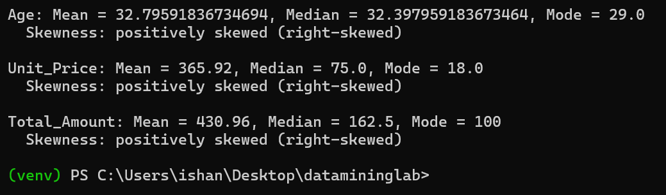

Outlier Detection (IQR Method)
Outliers were detected using the Interquartile Range (IQR) method:
- Q1 (25th percentile)
- Q3 (75th percentile)
- IQR = Q3 − Q1
Bounds:
- Lower Bound = Q1 − 1.5 × IQR
- Upper Bound = Q3 + 1.5 × IQR
Analyzing age:
Code:
col = 'Age'
Q1 = df[col].quantile(0.25)
Q3 = df[col].quantile(0.75)
IQR = Q3 - Q1
lower_bound = Q1 - 1.5 * IQR
print(f"{col} Q1 (25th percentile): {Q1}")
print(f"{col} Q3 (75th percentile): {Q3}")
print(f"{col} IQR: {IQR}")
print(f"{col} Lower bound (Q1 - 1.5*IQR): {lower_bound}")
upper_bound = Q3 + 1.5 * IQR
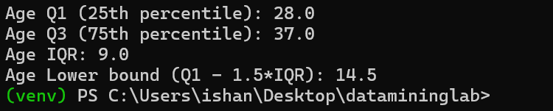

Calculate Q1, Q3, IQR, and Upper Bound
Code:
col = 'Total_Amount'
Q1 = df[col].quantile(0.25)
Q3 = df[col].quantile(0.75)
IQR = Q3 - Q1
lower_bound = Q1 - 1.5 * IQR
upper_bound = Q3 + 1.5 * IQR
print(f"{col} Q1: {Q1}")
print(f"{col} Q3: {Q3}")
print(f"{col} IQR: {IQR}")
print(f"{col} Lower bound: {lower_bound}")
print(f"{col} Upper bound: {upper_bound}")
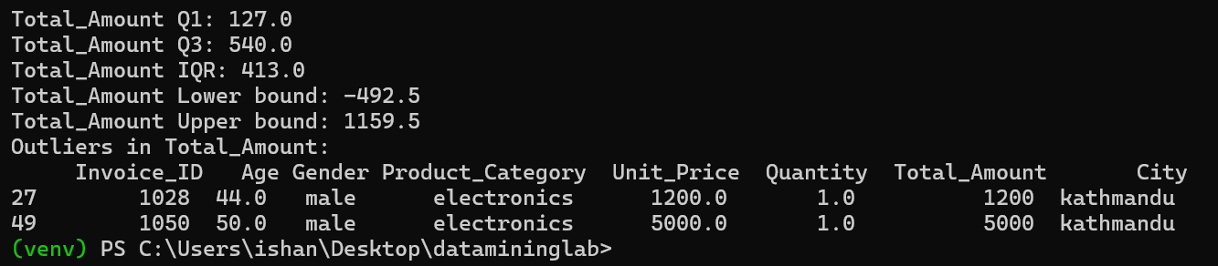

Outlier Treatment
Outliers were removed from the dataset to improve data quality and model performance.
Remove outliers OR cap them using upper bound
Code:
outliers = df[(df[col] < lower_bound) | (df[col] > upper_bound)]
print("Outliers in Total_Amount:\n", outliers)
df_no_outliers = df[(df[col] >= lower_bound) & (df[col] <= upper_bound)]
df[col] = df[col].apply(lambda x: upper_bound if x > upper_bound else (lower_bound if x < lower_bound else x))
removed_rows = df[~df.index.isin(df_no_outliers.index)]
print("\nRemoved outlier rows:\n", removed_rows)
capped_rows = outliers.copy()
capped_rows[col] = capped_rows[col].apply(lambda x: upper_bound if x > upper_bound else lower_bound)
print("\nCapped outlier rows:\n", capped_rows)
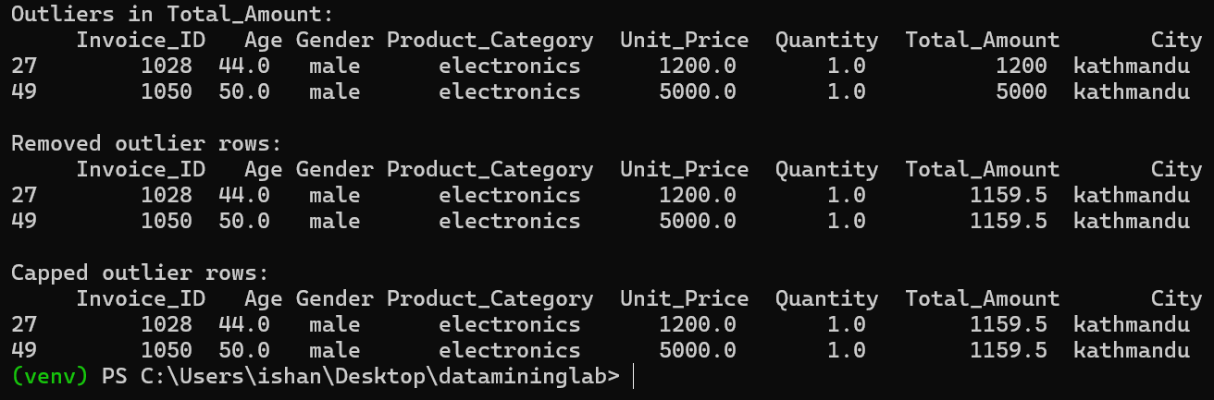

Feature Scaling
Min-Max Normalization was applied to Unit_price, Quantity and Total_Amount and Z-score Standardization was applied to Age
Min-Max Normalization
min_max_cols = ['Unit_Price', 'Quantity', 'Total_Amount']
for col in min_max_cols:
df[col + '_normalized'] = (df[col] - df[col].min()) / (df[col].max() - df[col].min())
print(df[min_max_cols + [c + '_normalized' for c in min_max_cols]].head())
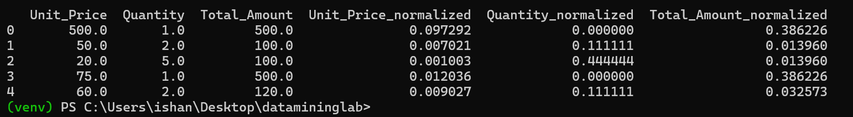

Standardization (Z-score)
df['Age_standardized'] = (df['Age'] - df['Age'].mean()) / df['Age'].std()
print(df[['Age', 'Age_standardized']].head())

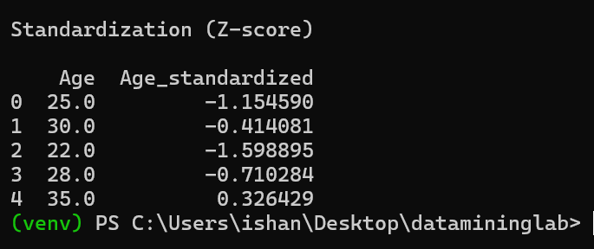

Encoding
Categorical variables (Gender, Product_Category, City) were converted into numerical format using One-Hot Encoding:
One-Hot Encoding for Categorical Variables
categorical_cols = ['Gender', 'Product_Category', 'City']
df_encoded = pd.get_dummies(df, columns=categorical_cols, drop_first=True)
print(df_encoded.head())
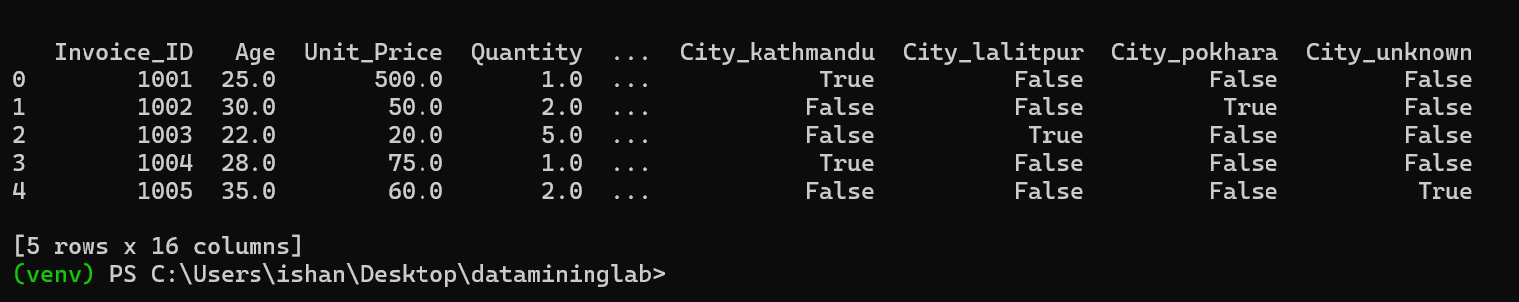

Final Output
The cleaned dataset was saved as cleaned_data.csv.
Save Cleaned Dataset
df_encoded.to_csv('cleaned_data.csv', index=False)
print("Cleaned dataset saved as cleaned_data.csv")
print(df.head(10))
